Electrotechnology Newsletter

TERM 4 2025

Welcome to all new students and parents, G’day to our existing students and parents and goodbye to our 2nd year students and parents. It’s Term 4, and our students are studying for the certificate II Electrotechnology Pre Vocational 22682VIC / 22499VIC.

First Year Students
Term 3 saw our students’ complete units UEECD0042 single path circuits, (series circuits). We worked hard at getting the first principles down, V = I x R and P = V x I. Students were requested to use their own calculator, to better prepare them for the Certificate III and the licencing exams at the end of their apprenticeships. We managed to put a few practical exercises in using 20mm PVC medium duty conduit to run the cables and wire up switches and lights.
Term 4, we commenced unit UEECD0020 Fix and Secure. This had us working with all sorts of fixing devices, such as self-drilling screws, pop rivets, wall mates, hollow wall fixings and masonry fixings. We got to use the hammer drills on our simulated brick walls as well as bending and threading steel conduit.
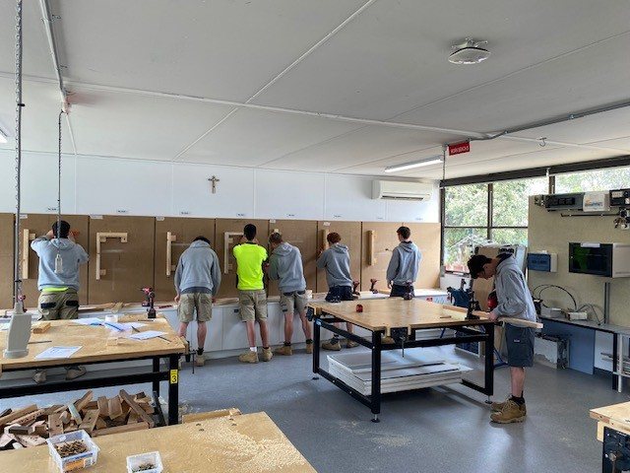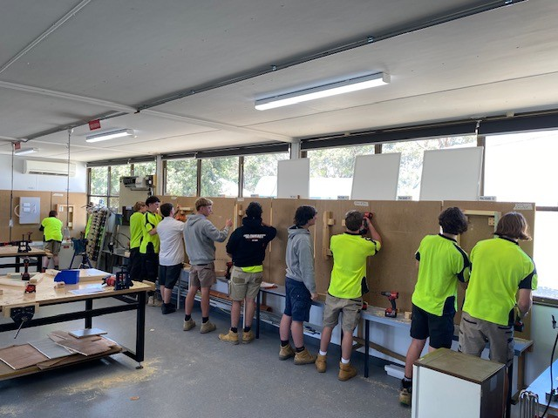
Just to bring things down to earth I introduced the old school “brace and bit”, just to show our students how life was before battery tools. Student Max Chitts managed to drill through 45mm pine the quickest with a time of 7.6 seconds. He was awarded a tape measure sponsored by the All Energy Expo 2025.
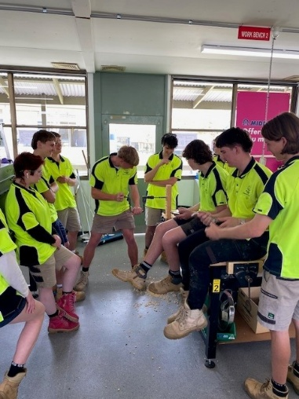

Second Year Students
Term 3 had our students start VU22672 Basic Project, where we cut, mounted and connected cable tray. They have used an angle grinder utilizing world best practices to ensure safety. Unit VU22673 Networking has been designed as the final year project. It incorporated the cable tray and used Cat 6 cable, RJ45 Connections for Ethernet communications, 75 Ohm RG6 Quad Shield connections for free to air television.
We had an excursion to Blue Scope Steel (BSL), with presentations from department managers, the apprentice master, current apprentices and the HR manager. BSL will be hiring 4 to 6 electrical apprentices this year and we wish those who applied the best of luck. Our students also had a visit from MEGT, Skillinvest and NECA. These not-for-profit organisations are group training organisations (GTO), where apprentices are essentially hired out to different electrical contractors. Apprentices are then usually assigned to large projects such as Victoria’s Big Build’s. Students were given the contact details and application procedures if they choose to pursue employment via a GTO.
Term 4 and we wrapped up the year / qualification with UEENEEP024A Attach Cords, Plugs and Sockets and UEENEEP026A Conduct In Service Testing (Testing and Tagging). This gave us 15 Units and the Certificate II of Electrotechnology was completed. Certificates were issued by AIET (our RTO) and distributed by Padua College.
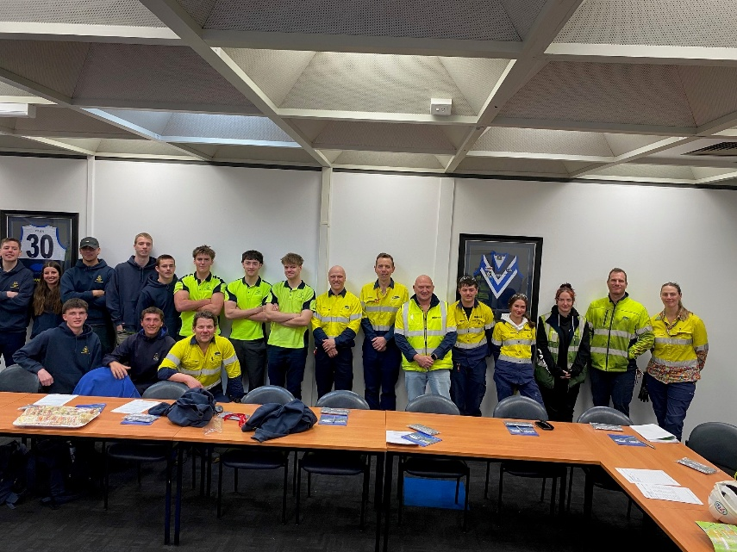

Padua College Middy’s High Achievers Awards
William Wallace and Cody Judkins were recognised in Term 3, then Kip Smyrk and Jai Ewer were rewarded in Term 4. Congratulations to those students, their names have been added to the High Achievers Awards board. The term 3 and 4 awards have been sponsored by the Electrical Trade Union.
The 2025 Pre Apprentice of the year was awarded to two students who we couldn’t separate. Cody Judkins and Jai Ewer completed their work on time, to a high standard continually over the course of Certificate II. Jai has a Bunnings voucher, Network tester and Volt Stick waiting for him to collect here at the Padua College VET Electrotechnology Facility (V140, V141). Congratulations to Jai, you’re an inspirational student and have been a pleasure to have in class. On behalf of the whole of Padua College Staff we wish you well with your future endeavours. Although Cody’s achievements are recognised posthumously our thoughts and prayers remain with him, his family, friends and classmates. It was a pleasure to have met you Cody you were and will always be a high achiever.
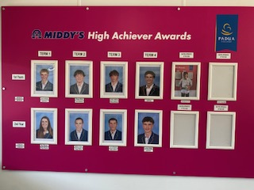

Kind regards,

Darell Faulkner
VET Teacher

